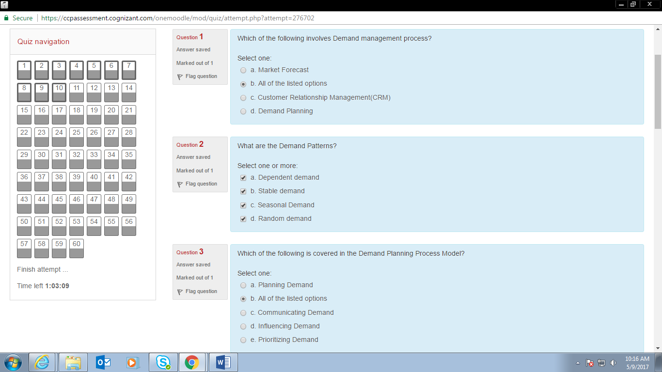

A01 Demand Management

S01 Demand pattern

A01 Demand planning process

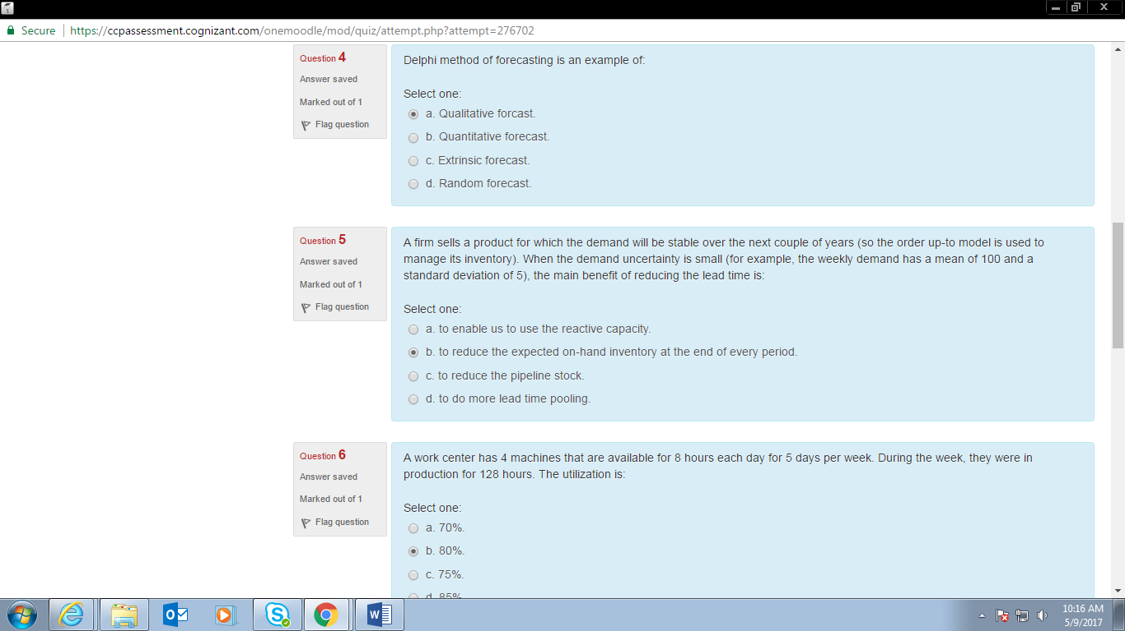

S01 Delphi

B01 A firm sells

PER01 A work center

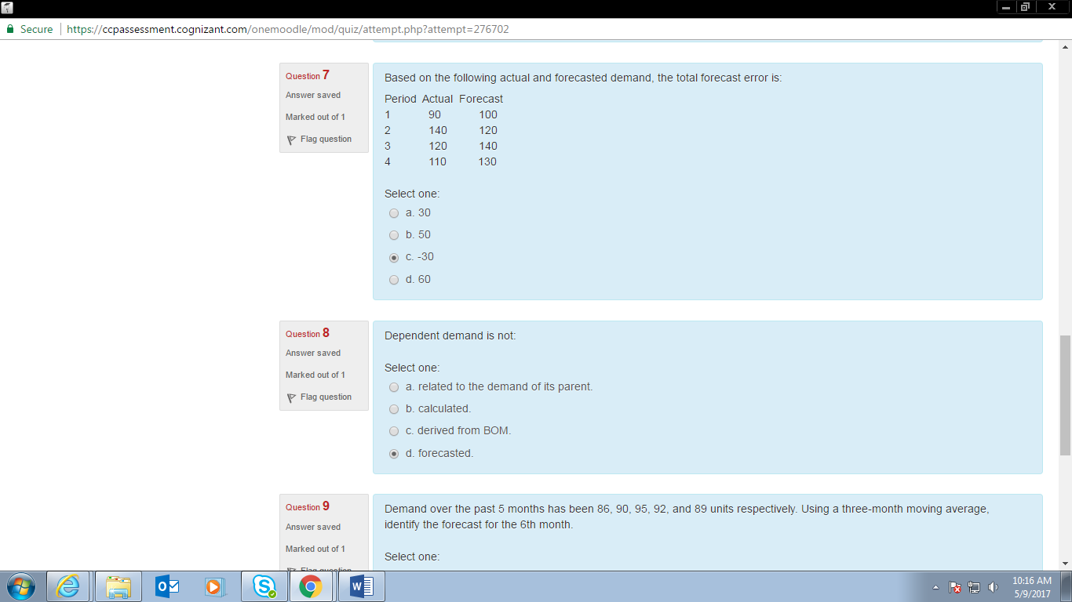

N01 Based on

S01 Dependent Demand is not

N01 Demand over past 5 months

A01 Planning levels are supported by forcasting

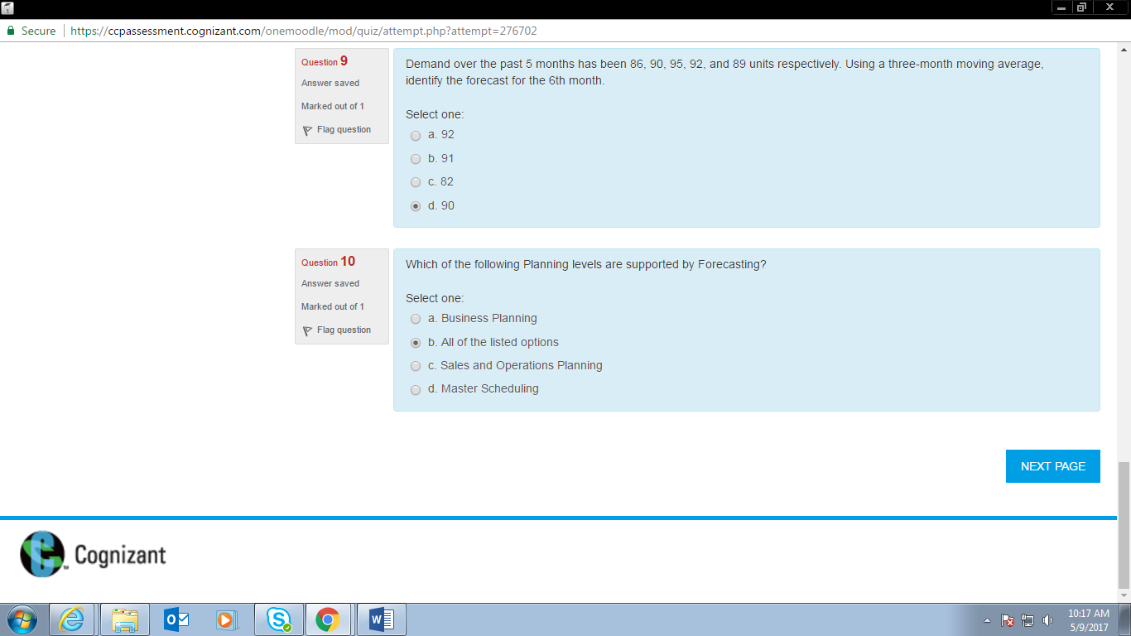

TF01 Stable demand retains

TF01 Quantitative technique is used

S01 Ordering costs

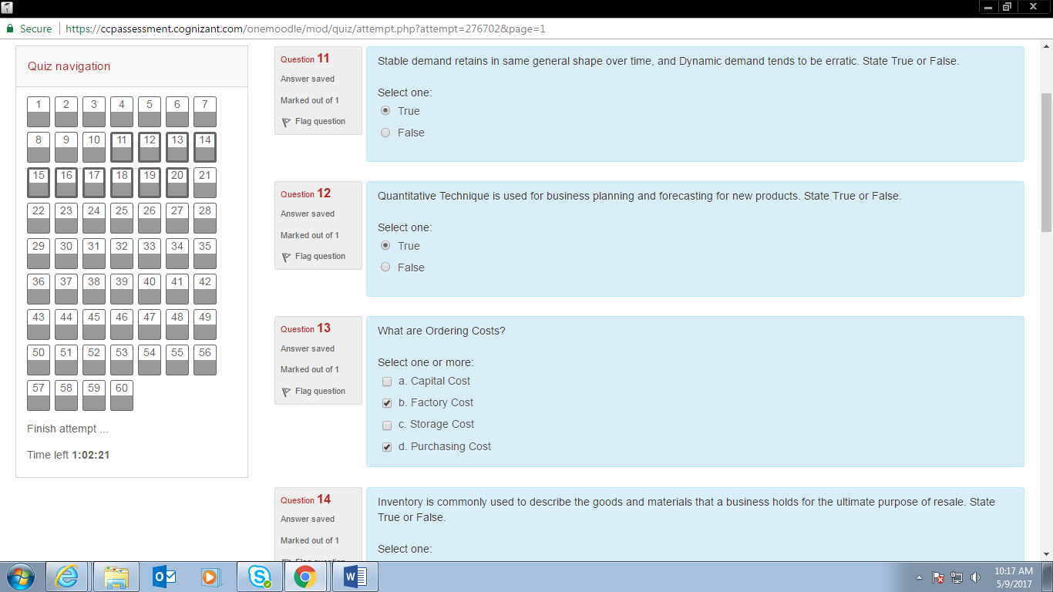

TF01 Inventory

S01 The fixed reorder cycle inventory

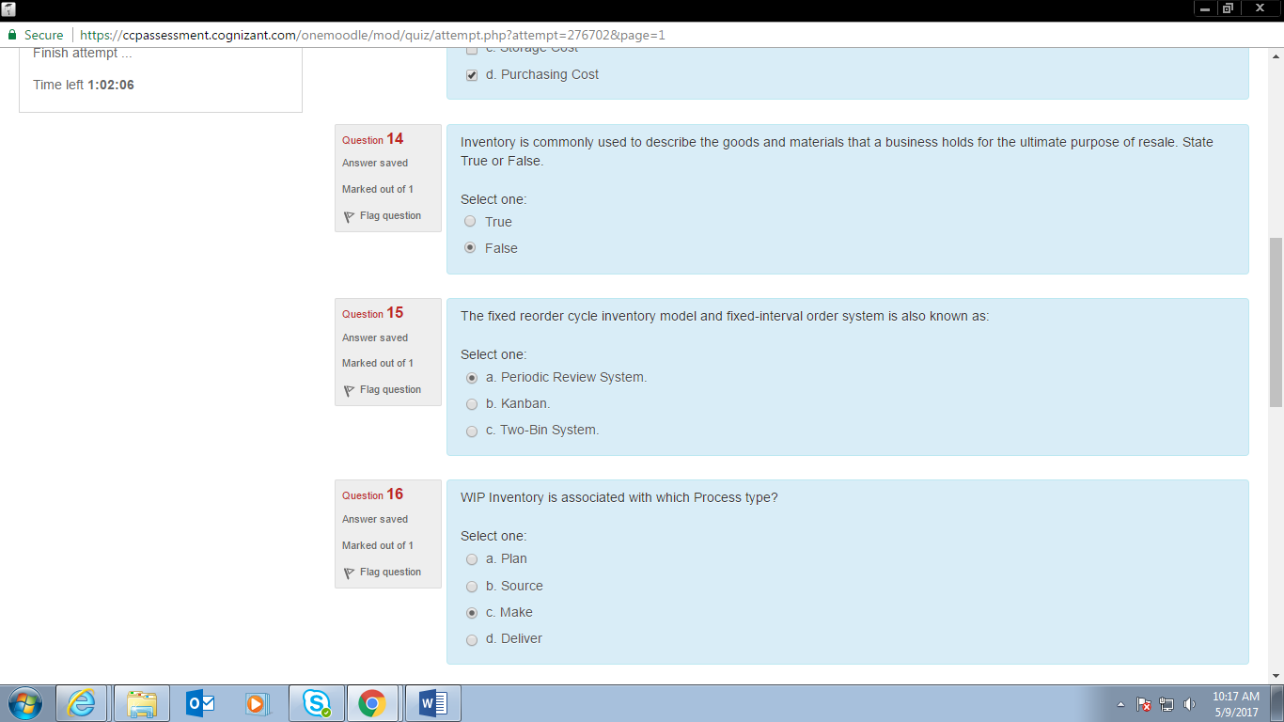

S01 WIP inventory

N01 A work center consists of three machines

TF01 Safety stock is used

N01 A work center has an order to process 500

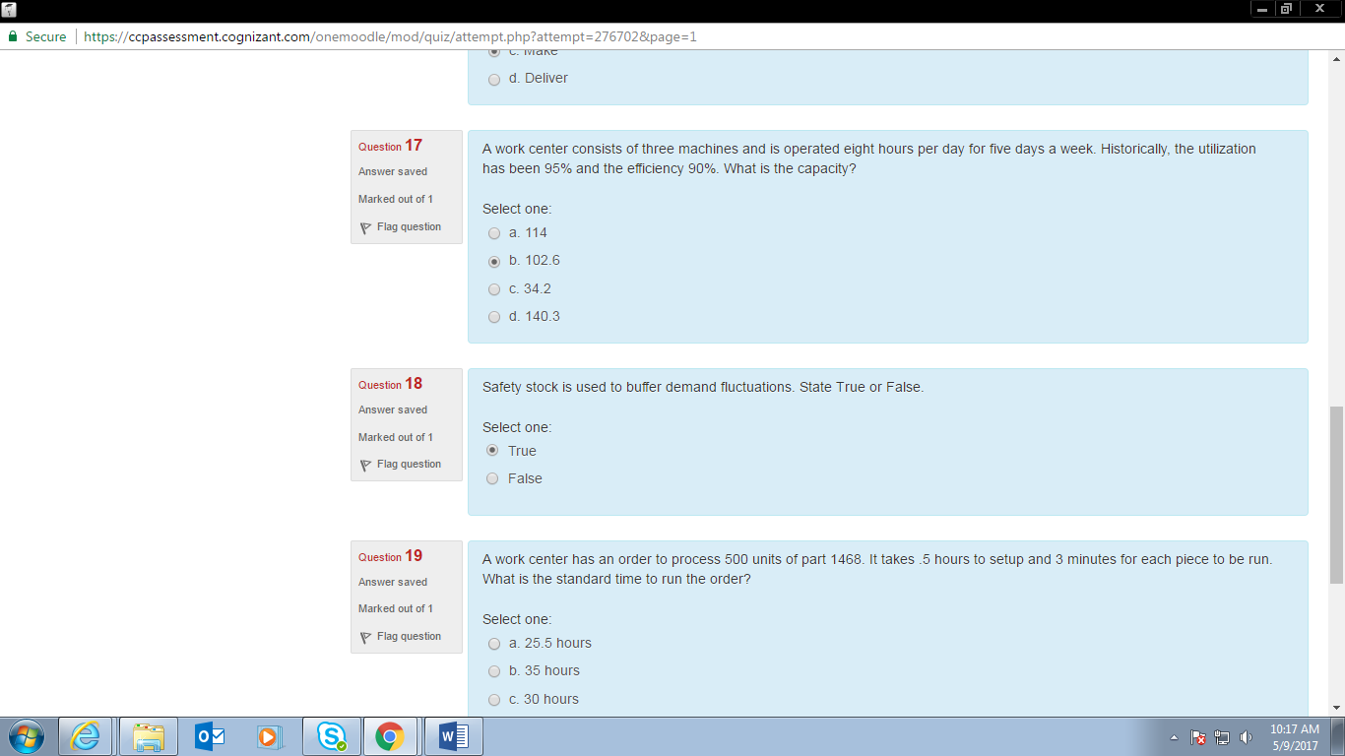

TF01 Inventory decouples customer demand

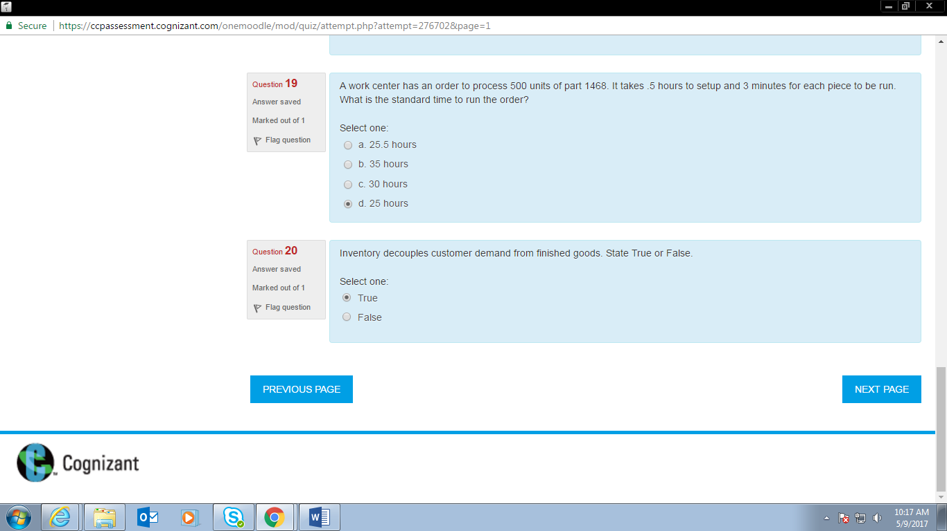

PER01 If a process that previously produced

N01 Cash flow has become a critical

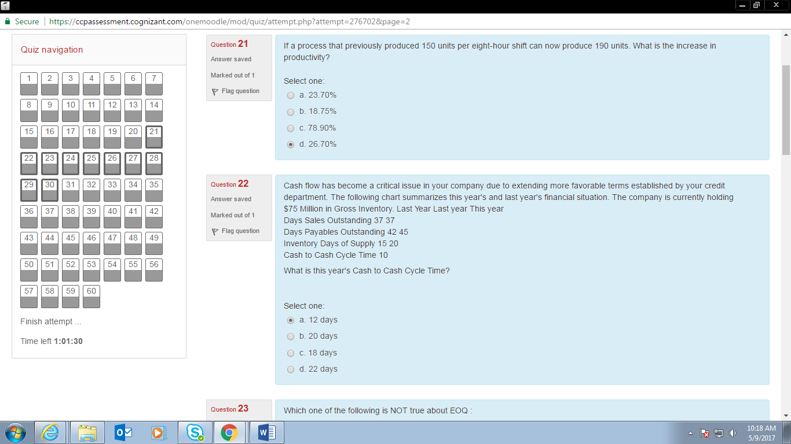

S01 Not true about EOQ

S01 Cost factors EOQ

TF01 Raw materials , semi finished

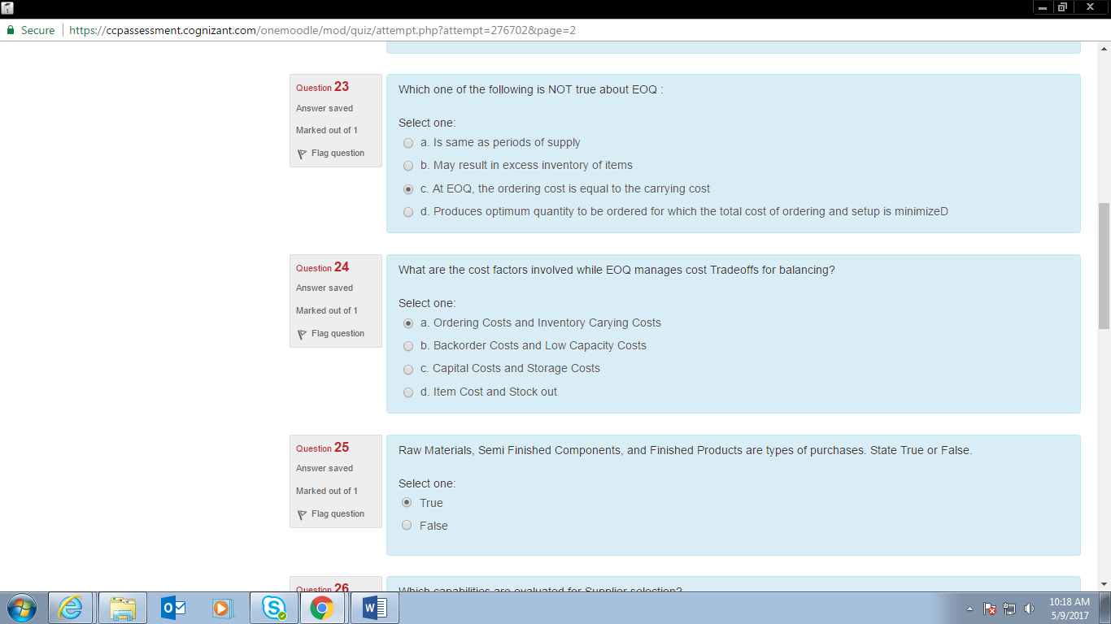

A01 Capabilities are evaluated for supplier selection

A01 Purchasing process

A01 Types of supplier relation

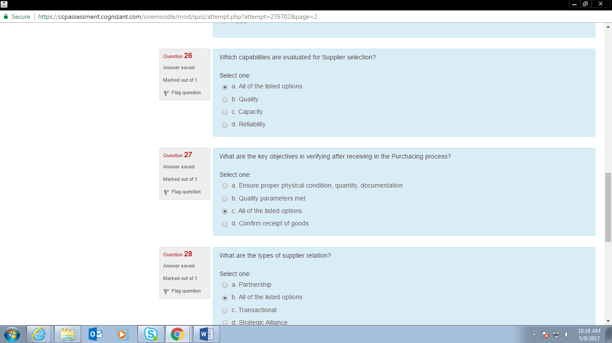

N01 Purchasing chessboard has x

PER01 If sales of a company is INR 4,7000

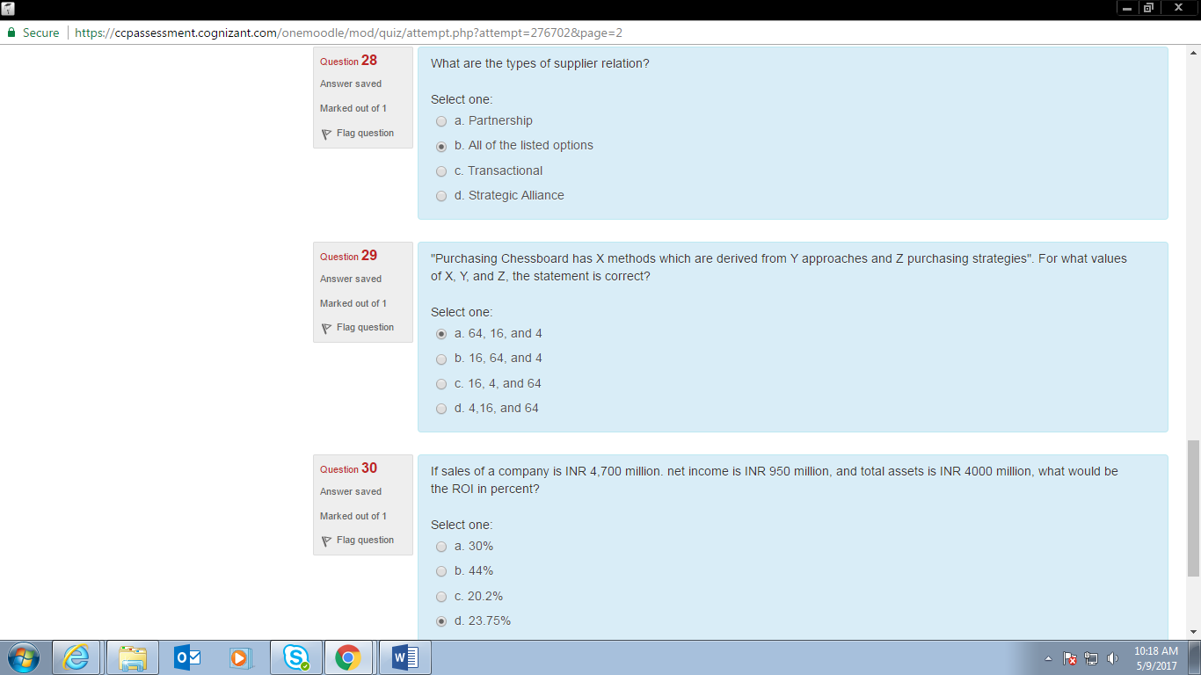

S01 A company produces a finished product

TF01 Strategic sourcing is not an

S01 Purchasing strategies

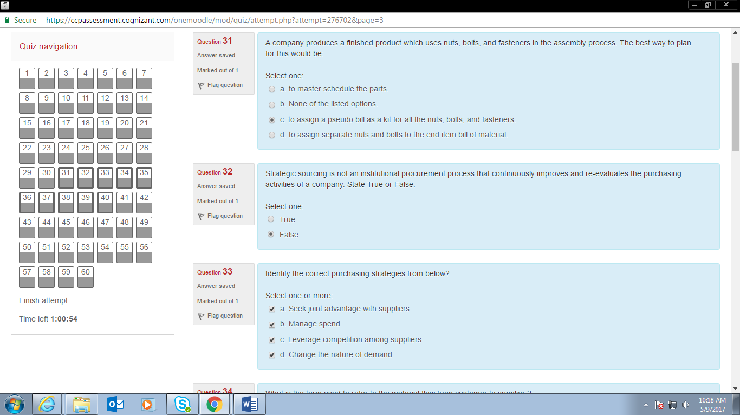

S01 Material flow from customer to supplier

S01 Supplier

S01 Supplier producer in supply chain network

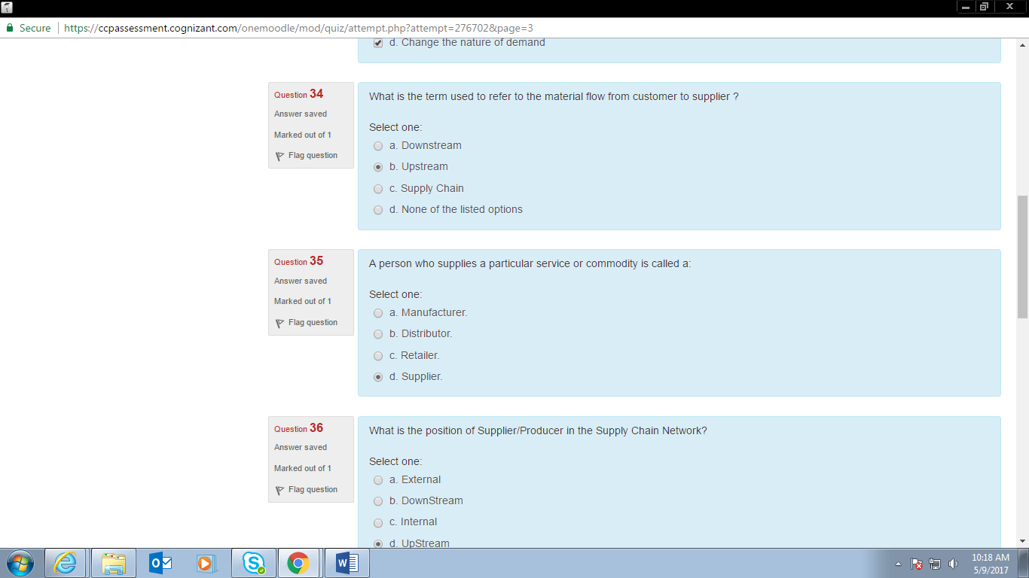

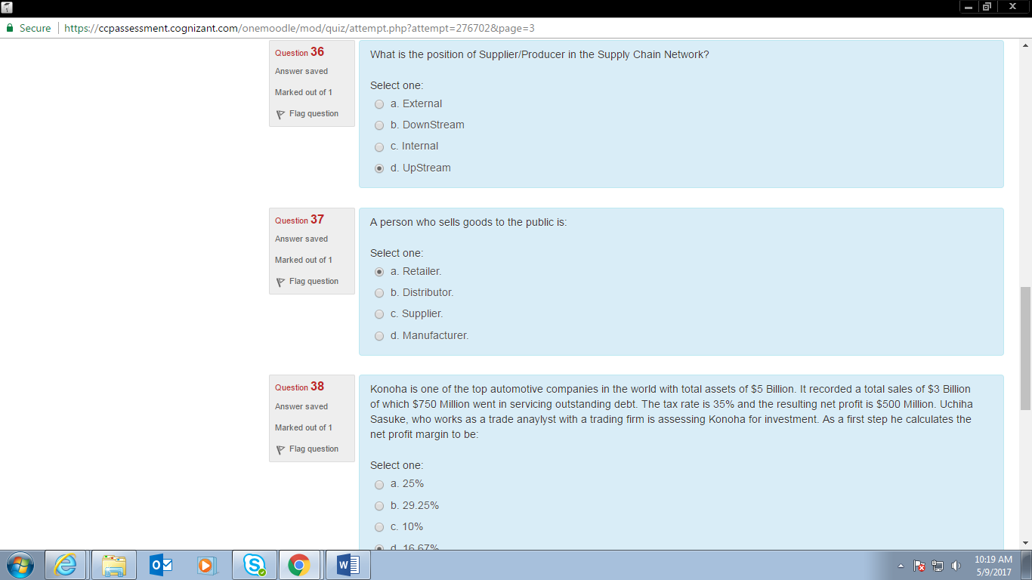

S01 Person who sells goods to the public

PER01 Konoha

S01 Net profit

A01 Supply chain

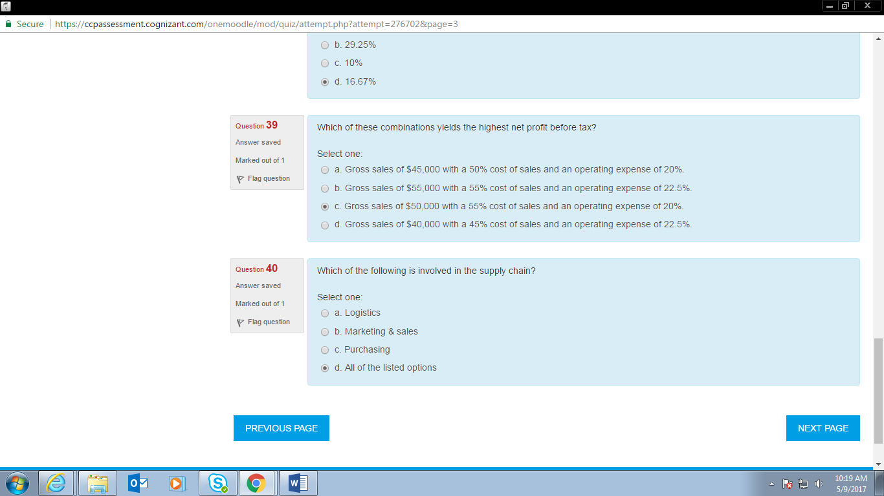

N01 Company ABC

S01 Manufacturing goods in supply chain network

PER01 Company XYZ

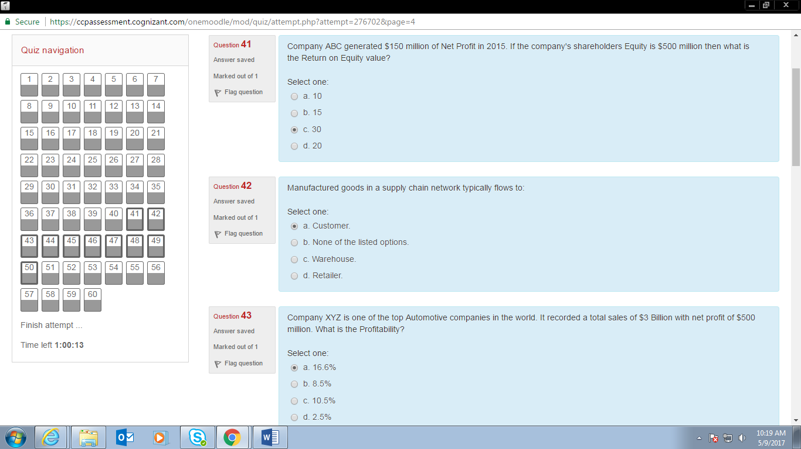

TF01 Deconsolidation

S01 Load building

S01 Sequence Dock scheduling

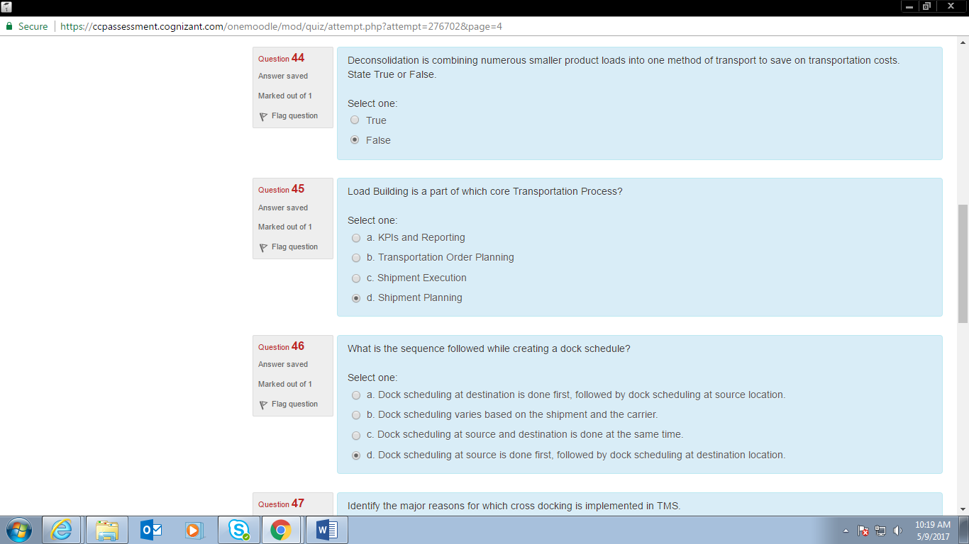

S01 Identify major reasons TMS

S01 What is the term used to denote cost incurred due to

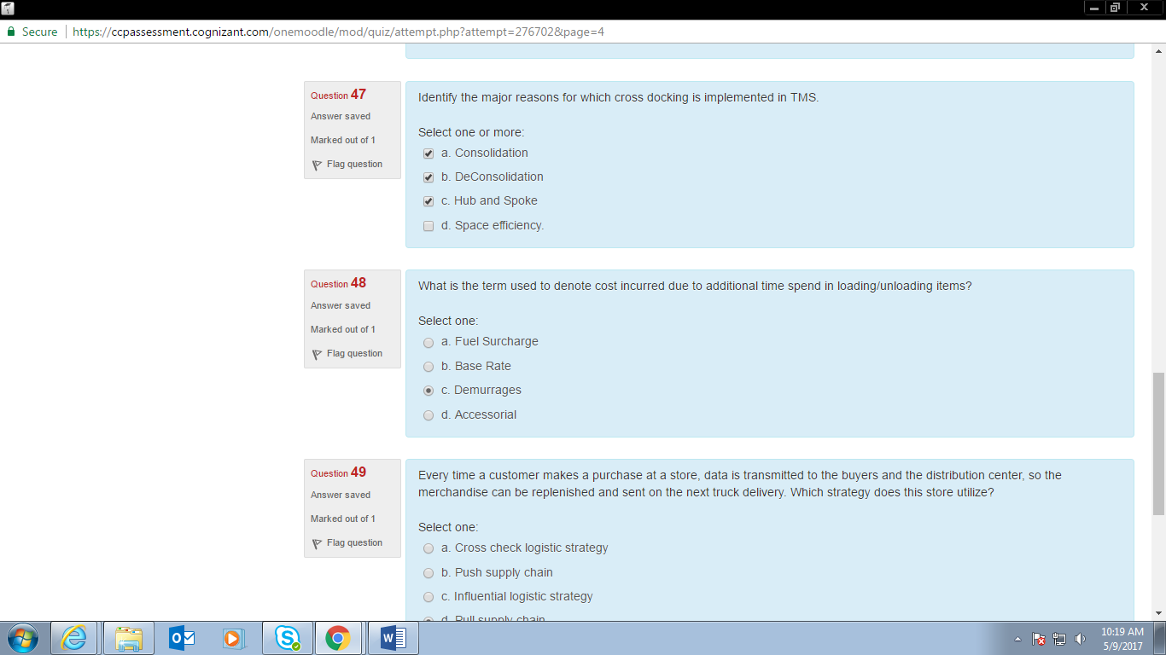

S01 Every time a customer

TF01 Cycle counting

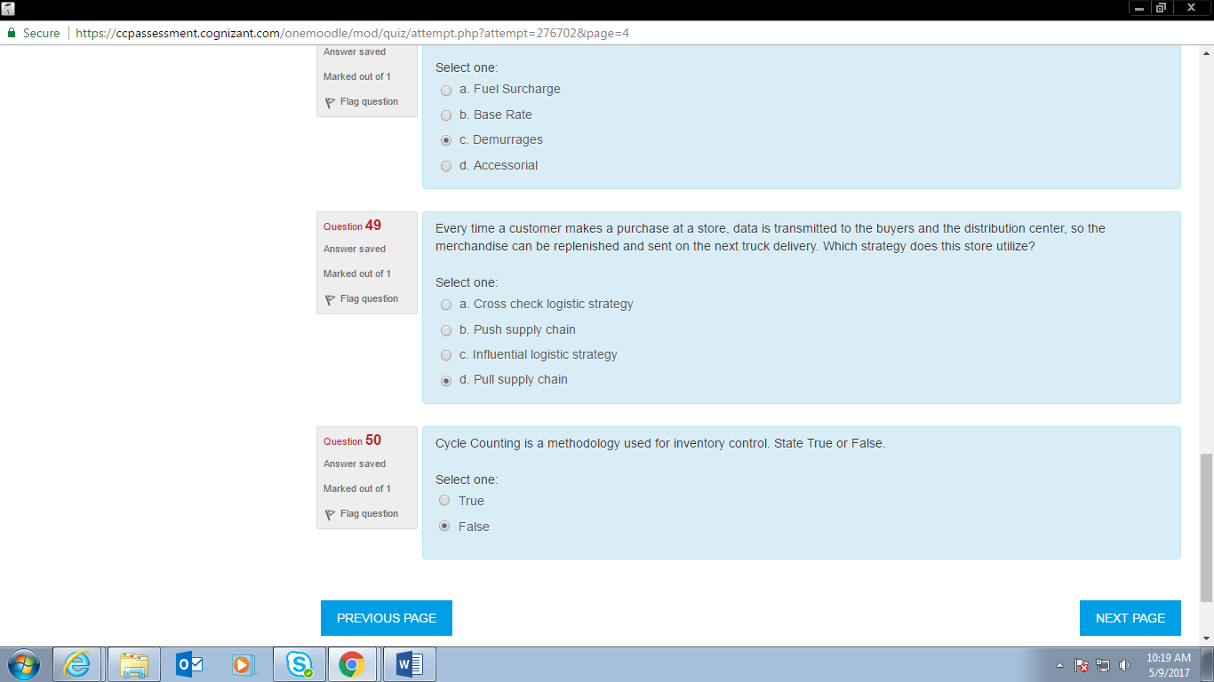

BIG01 William

S01 from the manufacturer to the warehouse

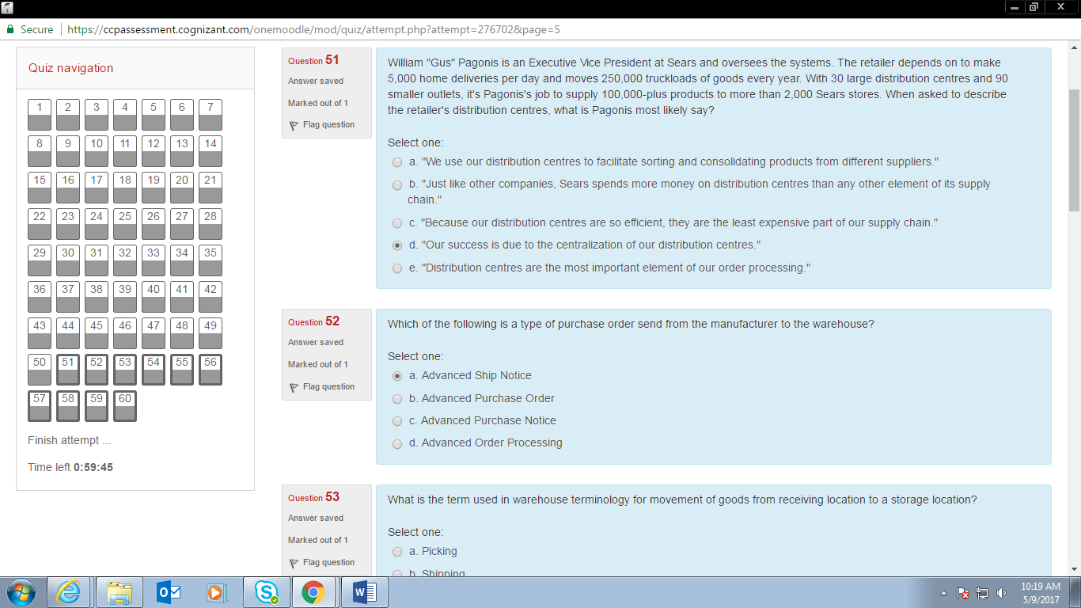

S01 terminology for movement of goods from receiving location to a storage location

S01 major out bound operation

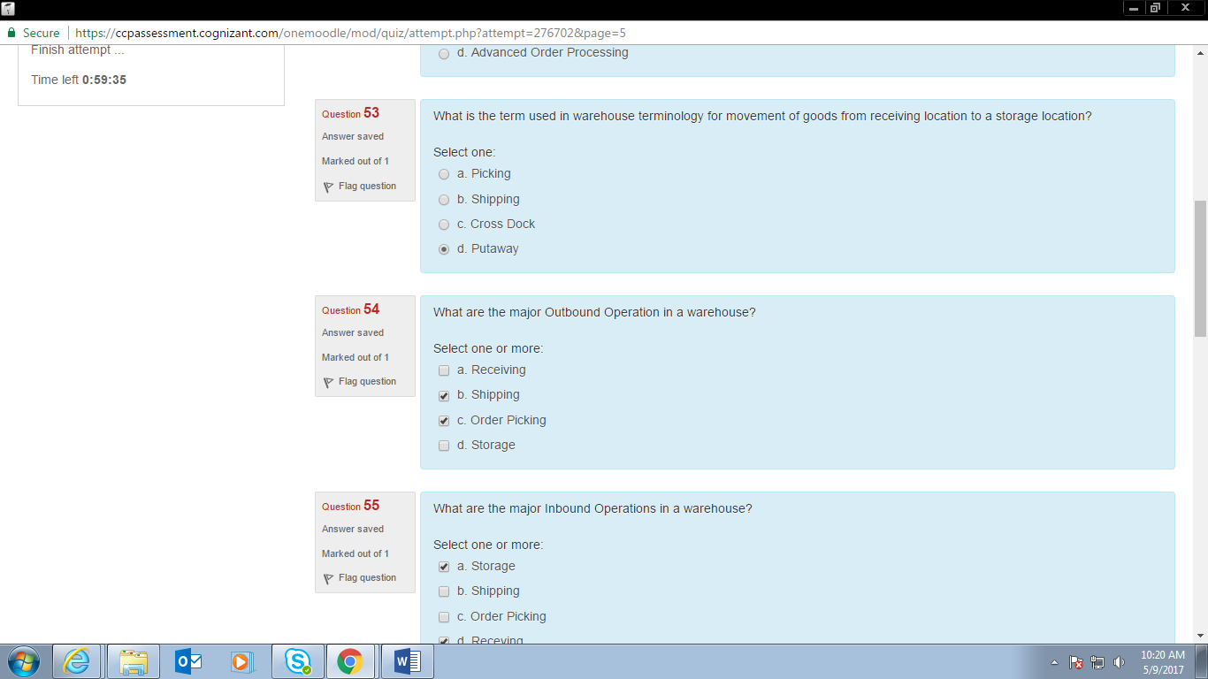

S01 the process of directly moving from a receiving location

S01 Universal Product Code

S01 process of WMS

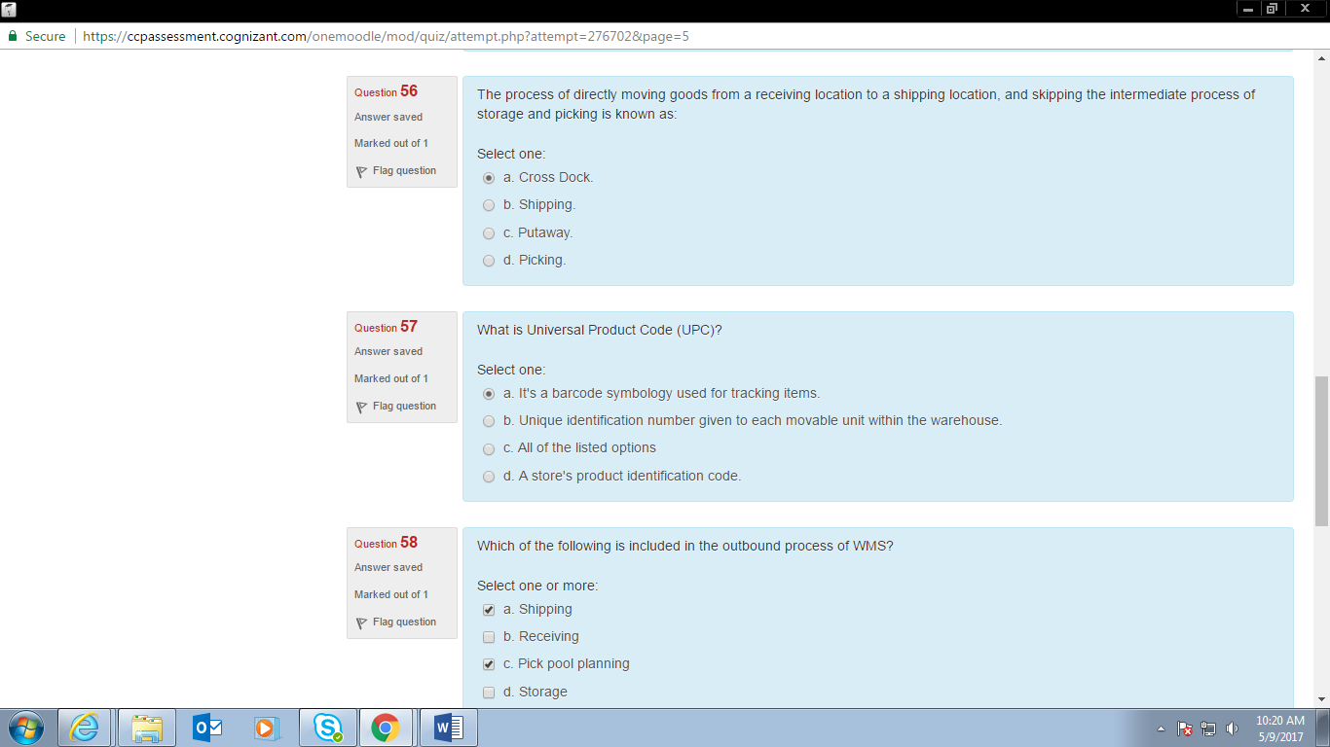

S01 inbound process of WMS

S01 challenge during putaway

